Early-Warning Predictive Maintenance Using a Baseline Isolation Forest and Multi-Stage Cascade Anomaly Detection Design
Danty D. Cook
Western Governors University
Data Analytics Capstone - D502
Task 3 Project Report

A. Project Overview

A.1 Research Question and Organizational Need
This capstone project focused on the need to identify abnormal equipment behavior before a recorded failure state. In a predictive maintenance setting, late detection can lead to unplanned downtime, rushed repairs, and inefficient use of maintenance resources. The project used industrial pump sensor data to evaluate whether abnormal patterns could be detected early enough to support maintenance review before failure is clearly visible.
The research question for this project was:
Does a multi-stage anomaly detection cascade improve alert quality compared with a single Isolation Forest baseline for industrial pump sensor data?
I evaluated this question from an operational perspective. The goal was not only to detect as many anomalies as possible. A model that catches every abnormal row but produces too many alerts may still be difficult for maintenance staff to use. For that reason, the project evaluated whether a cascade structure could reduce false positives, lower noisy alert volume, preserve useful anomaly sensitivity, and provide earlier evidence of abnormal pump behavior.

A.2 Project Scope
The project scope included a notebook-based analytical workflow organized into Bronze, Silver, and Gold stages, which follows the same general layered logic used in medallion architecture: progressively moving data from raw ingestion, to cleaned and enriched data, to analytics-ready outputs (Databricks, n.d.). The Bronze stage handled raw data ingestion and standardization. The Silver stage handled data cleaning, exploratory analysis, feature review, and clean-normal profiling. The Gold stage handled model-ready preprocessing, baseline modeling, cascade modeling, statistical comparison, and anomaly timeline review.
The core deliverables were:
- A Bronze preprocessing notebook for raw ingestion, validation, standardization, and lineage.
- Silver notebooks for pre-EDA, clean-normal profiling, feature review, and exploratory analysis.
- A Gold preprocessing notebook for feature preparation, episode-aware splitting, imputation, and scaling.
- A Gold baseline modeling notebook using a single Isolation Forest.
- Three Gold cascade modeling notebooks showing the progression from a default cascade, to a tuned cascade, to a Stage 3 improved cascade.
- A Gold comparison notebook with alert counts, precision, recall, F1 score, statistical tests, and comparison visuals.
- A Gold anomaly detection notebook with timeline review, lead-time summaries, and alert behavior outputs.
The project did not include a production deployment. It also did not treat synthetic data generation, Kafka, PostgreSQL, dashboarding, or full script-based automation as primary Task 3 deliverables. Those items were explored as supporting or future pipeline infrastructure. The submitted capstone evidence remained the notebook-based analytics workflow and the baseline-versus-cascade evaluation.

A.3 Solution Overview, Tools, and Methodology
The solution used a staged data workflow to move from raw pump sensor readings to a final model comparison. The Bronze layer created the standardized starting dataset. The Silver layer prepared the data for analysis by reviewing missingness, state behavior, and clean-normal reference groups. The Gold layer converted the data into model-ready features and compared the baseline and cascade models.
The primary tools used were Python, JupyterLab, pandas, NumPy, scikit-learn, matplotlib, Weights & Biases, Docker, WSL Ubuntu, and GitHub. pandas supported tabular data manipulation (pandas development team, n.d.), scikit-learn supported preprocessing and Isolation Forest modeling (scikit-learn developers, n.d.-a), Weights & Biases supported experiment artifact tracking (Weights & Biases, n.d.), and Docker supported a reproducible local development environment (Docker, Inc., n.d.). JupyterLab was useful because it kept the analysis, code, outputs, and explanations together in an auditable notebook workflow. Project ledgers and truth records supported artifact tracking and reproducibility.
The analytical design compared two model structures:
- Single-model baseline: A single Isolation Forest used as a broad anomaly detector.
- Multi-stage cascade: A staged design using broad screening, refined filtering, and final confirmation logic.
The cascade consisted of three stages:
- Stage 1 - Broad Isolation Forest screening: Preserved sensitivity by identifying a wide set of anomaly candidates.
- Stage 2 - Narrow Isolation Forest refinement: Reduced the broad Stage 1 alert pool using a more selective second model.
- Stage 3 - Confirmation layer: Used profile breaches, secondary sensor corroboration, persistence, drift behavior, and weighted evidence to produce a more selective final alert stream.
The staged design was supported by prior anomaly-detection literature showing that cascade structures can reduce unnecessary review or computation by applying broad screening before more specific confirmation steps (Bose et al., 2025; Zhou et al., 2024). The project’s use of profile and rule confirmation also aligns with work on statistical condition-monitoring profiles and alarm validation, where interpretability and confirmation matter alongside raw anomaly detection (Tam & Nguyen, 1995; Zhang et al., 2019).
This design was appropriate because the dataset was highly imbalanced and contained very few broken rows. Isolation Forest and related outlier-detection approaches are appropriate for identifying unusual observations when labeled failure examples are limited (scikit-learn developers, n.d.-a; scikit-learn developers, n.d.-b). In that setting, standard accuracy is not a useful success measure. The project therefore evaluated alert quality using alert counts, false positives, precision, recall, F1 score, statistical tests, and early-warning timeline behavior.

B. Project Execution

B.1 Differences from the Task 2 Plan
The project followed the main structure proposed in Task 2, but the work became more iterative and detailed than the original plan. Task 2 defined a Bronze, Silver, and Gold workflow and proposed a comparison between a single Isolation Forest baseline and a multi-stage cascade. That structure was completed, but several implementation details changed as the data and model behavior were examined.
The largest change occurred in the Silver stage. The original plan included cleaning, missing-value review, feature behavior analysis, and exploratory data analysis. During execution, I found that the original NORMAL label could not automatically be treated as a clean normal reference. Some normal-labeled rows appeared less stable and more similar to developing abnormal behavior. Because of this, the Silver stage was expanded to include clean-normal profiling and profiled-state creation. This change strengthened the project because the Gold models could be evaluated against a more carefully reviewed understanding of normal behavior.
The Gold stage also expanded. Instead of building only one cascade notebook, I separated the cascade work into three modeling notebooks. Gold 03A tested the default cascade design. Gold 03B added Stage 2 tuning and threshold search. Gold 03C added the improved Stage 3 confirmation layer. This made the final model comparison clearer because each notebook showed how the cascade design developed from a basic staged filter into a more selective alert-confirmation process.
The statistical evaluation also expanded. Task 2 planned a false-positive-focused statistical comparison. I kept that comparison, but I added a paired McNemar test, a false-positive-rate z-test, a precision z-test, and operational alert-quality metrics. This was necessary because the dataset was extremely imbalanced. A p-value alone would not explain whether the model output was useful for maintenance review, so the final evaluation combined statistical evidence with practical metrics.

B.2 Planning Methodology Differences
The planned methodology was a staged Bronze, Silver, and Gold process. That methodology remained in place, but the actual workflow became more iterative. Results from later stages caused earlier stages to be revisited and improved.
For example, the need for a reliable normal reference became clear during modeling preparation. That pushed additional work back into the Silver layer, where normal-labeled rows were profiled and separated into cleaner and less stable groups. Similarly, the first cascade result showed that a fixed cascade was not enough to achieve the best practical result. That led to Stage 2 tuning in Gold 03B and Stage 3 confirmation improvements in Gold 03C.
This iterative execution was appropriate for the project. Anomaly detection work often requires repeated review of feature behavior, thresholds, class imbalance, and alert patterns. The final workflow still followed the planned architecture, but it used feedback from the data and model outputs to improve the final analysis.

B.3 Timeline and Milestone Differences
The Bronze stage stayed closest to the original plan because raw ingestion and standardization were straightforward compared with later stages. The Silver and Gold stages required more time than expected.
The Silver stage expanded because clean-normal behavior had to be profiled before reliable model-ready data could be created. This was not originally planned at the same level of detail, but it became necessary after reviewing the data. The Gold stage expanded because the cascade model was developed through several versions rather than one final model. This added work, but it also created a stronger final comparison.
The original plan also allowed for a light pipeline-ready structure. During execution, I explored some future-oriented supporting framework work, including synthetic data, Kafka, and PostgreSQL concepts. Kafka was treated as supporting infrastructure for possible later streaming simulation rather than as a core capstone deliverable (Confluent, n.d.). The final submission focuses on the completed notebook-based analytics workflow, model comparison, statistical evaluation, and timeline review.
Notebook-to-script conversion was also moved to future work. The notebooks were organized to support later refactoring, but the final capstone evidence is the executed notebook workflow rather than a production-hardened pipeline.

C. Data Selection and Collection Process

C.1 Data Selection and Collection
The selected dataset was the publicly available Pump Sensor Data dataset from Kaggle (nphantawee, n.d.). The dataset contains multivariate time-series readings from an industrial pump system, including timestamped observations, 52 sensor columns, and a machine-status field with normal, broken, and recovering states.
The dataset was appropriate for this capstone because it matched the predictive maintenance problem. It included industrial sensor telemetry, rare failure labels, time-based behavior, missing values, and noisy sensor patterns. These characteristics made it suitable for evaluating anomaly detection and alert-quality improvement.
The data collection process differed from the Task 2 plan mainly in the amount of derived project data created after collection. The raw source remained the Kaggle dataset, but the project produced additional internal outputs through Bronze, Silver, and Gold processing. These outputs included standardized Bronze data, Silver profiling artifacts, Gold model-ready datasets, model predictions, statistical summaries, and visualizations.

C.2 Obstacles Encountered During Collection and Preparation
The main obstacle was not access to the data because the dataset was publicly available. The larger challenge was determining how to use the data responsibly for anomaly detection.
The first obstacle was class imbalance. The dataset contained very few broken rows compared with normal and recovering rows. This meant that standard accuracy would be misleading and that recall, precision, F1 score, false positives, alert counts, and timeline behavior would be more useful.
The second obstacle was missing sensor data. Some sensors had substantial missingness, and at least one sensor was entirely null. These columns had to be reviewed before modeling so the models would not learn from unusable features.
The third obstacle was the quality of the normal label. During Silver analysis, I found that not all normal-labeled rows behaved like clean normal operation. Some appeared suspicious or contaminated by developing abnormal behavior. This led to the creation of profiled normal groups and a cleaner normal reference.
These obstacles were handled by reviewing missingness, quarantining problematic features, creating normalized state fields, profiling normal behavior, using episode-aware splitting, and evaluating models with alert-quality metrics rather than accuracy alone.

C.3 Data Governance Issues
The dataset was publicly available and did not contain direct personal identifying information. The main governance concerns were therefore reproducibility, traceability, and responsible interpretation rather than privacy.
To support reproducibility, the project used staged outputs, metadata fields, truth records, ledgers, and saved artifacts. These elements helped preserve the relationship between raw data, transformed data, model-ready data, model outputs, and final comparison results.
To support responsible interpretation, the final report avoids claiming that the model is production-ready or that it guarantees failure prediction. The results are interpreted as evidence that the cascade improved alert quality and identified abnormal behavior before the recorded broken state in the evaluated sequence. This distinction matters because false positives and false negatives both have practical consequences in predictive maintenance.

C1. Advantages and Limitations of the Dataset

Advantages
The dataset had several advantages for this project. It was directly related to the use case because it contained industrial pump sensor readings. It was also time-based, which allowed the project to evaluate not only whether anomalies were detected, but also when alerts occurred relative to the first broken row. In addition, the dataset contained many sensor columns, making it appropriate for multivariate anomaly detection. Finally, it included realistic data quality issues such as missing values, noisy readings, and class imbalance.
These characteristics made the dataset useful for testing whether a staged alerting approach could produce a more practical result than a single broad anomaly detector.

Limitations
The dataset also had important limitations. The largest limitation was severe class imbalance. There were very few broken rows compared with normal and recovery rows, which made accuracy inappropriate as a primary metric and made precision difficult to improve.
A second limitation was label quality. The broken label identified recorded failure periods, but the normal label did not guarantee that all normal-labeled rows represented stable normal behavior. This required additional clean-normal profiling.
A third limitation was missingness. Some sensors had enough missing data to require exclusion or special handling. A fourth limitation was generalizability. The dataset represented one pump system, so the final thresholds and rules should not be assumed to generalize to all industrial equipment without additional validation.
A final limitation was that the project evaluated a historical dataset rather than a live production system. The results support the usefulness of the cascade in this analytical environment, but production use would require additional data, operational validation, monitoring, and deployment testing.

D. Data Extraction and Preparation

D.1 Data Extraction
The data extraction process began with the raw Kaggle pump sensor CSV file (nphantawee, n.d.). The Bronze notebook loaded the raw file, checked the expected structure, preserved the timestamp and sensor fields, added metadata, and saved the standardized Bronze output.
This approach was appropriate because it created a stable starting point for downstream work. Instead of each notebook reading directly from the raw CSV, later stages used governed project outputs with consistent metadata and lineage.
The extraction process included:
- Loading the raw CSV file.
- Validating expected fields.
- Preserving timestamp, sensor, and status columns.
- Adding project metadata and lineage fields.
- Saving Bronze outputs for downstream processing.
- Writing supporting summaries and truth records.

D.2 Data Preparation
The Silver and Gold layers performed the main preparation work. In Silver, the project resolved machine-status labels, reviewed missingness, created time and episode fields, identified usable sensor features, and built profiled state categories. The clean-normal profiling step became especially important because the original normal label was not specific enough for reliable model training and interpretation.
In Gold, the project selected model-ready numeric features, applied imputation, scaled the data, created an episode-aware train/test split, and saved the outputs needed by the baseline and cascade models. The episode-aware split was used because the dataset is time-based. A random row split could leak related observations from the same operating episode into both training and testing. Holding out full episodes created a more appropriate evaluation structure.
Imputation was used because model-ready sensor features could contain missing values. Scaling was used because sensor values could appear on different ranges. Robust scaling was appropriate because industrial sensor data can contain spikes and extreme values; RobustScaler uses statistics that are more resistant to outliers than standard mean-and-variance scaling (scikit-learn developers, n.d.-d).

D.3 Why These Processes Were Appropriate
The extraction and preparation processes were appropriate because the dataset was multivariate, time-based, noisy, incomplete, and highly imbalanced. Raw modeling would not have been sufficient.
Missingness review prevented unusable sensor columns from distorting the model. Clean-normal profiling improved the reliability of the normal reference. Episode-aware splitting reduced leakage risk. Imputation and scaling prepared the features for Isolation Forest modeling. Alert-quality metrics and statistical tests supported evaluation in a setting where standard accuracy would be misleading.
Together, these processes created a defensible path from raw data to final model comparison.

E. Data Analysis Process

E.1 Analytical Methods Used
The main analytical method used in this project was anomaly detection. This approach fits industrial monitoring problems where the goal is to identify unusual operating behavior from sensor or inspection data instead of relying only on fully supervised failure labels (Gómez et al., 2023; Himeur et al., 2021; scikit-learn developers, n.d.-b). It was appropriate here because the dataset did not contain enough labeled failures for a conventional supervised classification project. Instead, the analysis focused on whether unusual sensor patterns could be detected and whether the resulting alerts were useful enough for maintenance review.
The project used the following analytical methods:
- Exploratory data analysis: I reviewed dataset structure, missingness, sensor distributions, state labels, time behavior, outlier patterns, and feature relationships.
- Clean-normal profiling: I separated more stable normal-labeled rows from suspect or contaminated normal-labeled rows. This helped create a better normal reference for modeling.
- Feature preparation: I selected usable numeric sensor features, excluded problematic columns, imputed missing values, and scaled the model-ready features.
- Baseline anomaly detection: I trained a single Isolation Forest baseline to create a high-sensitivity reference model.
- Cascade anomaly detection: I developed a multi-stage cascade to test whether staged filtering could improve alert quality.
- Statistical comparison: I used a paired McNemar test, false-positive-rate z-test, and precision z-test to evaluate whether the cascade differed from the baseline.
- Timeline validation: I reviewed where alerts occurred relative to the first broken row to evaluate early-warning evidence.
The baseline model used one Isolation Forest as a broad anomaly detector (scikit-learn developers, n.d.-a). The cascade used three stages. This staged design was also consistent with published cascade approaches that use early screening and later confirmation to improve efficiency, focus, or interpretability in anomaly detection systems (Bose et al., 2025; Zhou et al., 2024). Stage 1 screened broadly for anomaly candidates. Stage 2 used a second Isolation Forest to refine the Stage 1 candidate pool. Stage 3 used rule-based confirmation logic based on profile breaches, secondary sensor corroboration, persistence, drift behavior, and weighted evidence.
This design directly matched the research question. The baseline answered whether a single Isolation Forest could detect anomaly signal in the data. The cascade answered whether a staged approach could produce a cleaner and more operationally useful alert stream.

E.2 Advantages and Limitations of the Tools and Techniques

Advantages
Isolation Forest was appropriate because it is designed for anomaly detection and can be used when labeled failure examples are limited. This was important for this project because the dataset contained very few broken rows. Isolation Forest can also evaluate multivariate sensor behavior, which makes it useful for identifying unusual combinations of readings across many pump sensors.
The cascade structure was useful because it separated broad detection from final alert confirmation. A single broad model can detect unusual behavior, but it can also produce too many weak alerts. The cascade allowed the first stage to keep sensitivity while later stages reduced the alert pool. This better matched the maintenance goal of producing alerts that are more practical to review.
The clean-normal profiling step was also useful because it addressed a weakness in the source labels. The original normal label did not guarantee that every normal-labeled row was a stable example of normal operation. Profiling helped identify cleaner normal behavior and made the later modeling process more defensible.
The statistical tests strengthened the comparison. The metrics used for precision, recall, and F1 followed standard classification-evaluation definitions (scikit-learn developers, n.d.-c). The McNemar test was appropriate because the baseline and Stage 3 Improved cascade were evaluated on the same test rows, which created a paired comparison structure (statsmodels developers, n.d.). The false-positive-rate test supported the planned hypothesis that the cascade would reduce false positives during normal periods. The precision test evaluated whether the cascade improved the concentration of true anomaly detections within the alert stream.

Limitations
The main limitation of Isolation Forest is that it identifies unusual rows but does not automatically explain the operational cause of each alert. Additional analysis is needed to connect a flagged row to a specific equipment issue.
A second limitation is that threshold choices strongly affect results. Lower thresholds can increase recall but create many alerts. Stricter thresholds can improve precision but miss some abnormal behavior. This is why the project compared multiple cascade versions and Stage 3 operating modes instead of selecting a model based on one metric alone.
A third limitation is that the Stage 3 confirmation rules depend on project-specific assumptions about profile breaches, persistence, drift, and sensor corroboration. Rule-based alarm validation and statistical operating profiles can support interpretability, but they still require domain validation before operational use (Tam & Nguyen, 1995; Zhang et al., 2019). These rules improved alert quality in this project, but they would need additional validation before being used in a production maintenance system.
A fourth limitation is that statistical significance does not automatically prove practical usefulness. With many row-level observations, a model comparison can be statistically significant even when the practical improvement is small. For that reason, the project also evaluated alert reduction, precision, recall, F1 score, early-warning behavior, and model interpretability.

E.3 Step-by-Step Application of Analytical Methods

Step 1: Bronze ingestion and standardization
The raw pump sensor data was loaded in the Bronze preprocessing notebook. The notebook validated the dataset structure, preserved sensor and status fields, added metadata, and saved a standardized Bronze output. This created a traceable starting point for the rest of the project.

Step 2: Silver cleaning and readiness checks
The Silver Pre-EDA notebook reviewed the data for missingness, state labels, duplicate or structural issues, timestamp behavior, and usable sensor columns. This stage created normalized status fields, anomaly indicators, and time or episode fields needed for downstream analysis.

Step 3: Clean-normal profiling
The Silver subset and profiling workflow reviewed the normal-labeled rows more carefully. This step was added because some normal-labeled rows appeared less stable than others. The profiling process separated cleaner normal behavior from suspect or contaminated normal-labeled behavior. This improved the quality of the normal reference used later in the project.

Step 4: Exploratory data analysis
The Silver EDA notebook examined state distributions, sensor behavior, missingness, correlations, PCA patterns, sensor shifts, and outlier behavior. This supported the modeling design by showing that sensor behavior differed across profiled states and that the dataset contained structure that could support anomaly detection.

Step 5: Gold preprocessing
The Gold preprocessing notebook selected numeric sensor features, applied imputation, scaled the features, and created an episode-aware train/test split. An episode-aware split was used instead of a random row split because the data is time-based. Holding out full episodes reduced the risk of leakage from related operating periods.

Step 6: Baseline Isolation Forest modeling
The Gold 02 notebook trained the single Isolation Forest baseline. This model established the reference point for broad anomaly detection. It was used to determine whether anomaly signal existed in the data and to create a benchmark for alert volume, precision, recall, and F1 score.

Step 7: Default cascade modeling
The Gold 03A notebook introduced the first cascade model. Stage 1 screened broadly, Stage 2 refined the alert candidates, and Stage 3 applied initial confirmation logic. This tested whether staged filtering could reduce alert volume compared with the baseline.

Step 8: Tuned cascade modeling
The Gold 03B notebook improved the cascade by adding Stage 2 tuning and threshold search. This allowed the cascade to test different Stage 2 configurations and select a stronger refinement model.

Step 9: Stage 3 improved cascade modeling
The Gold 03C notebook kept the tuned Stage 2 configuration and added a stronger Stage 3 confirmation layer. The final confirmation logic used profile breaches, secondary sensor evidence, rolling persistence, drift behavior, and weighted scoring. This made the final cascade output more selective.

Step 10: Model comparison and statistical testing
The Gold 04 comparison notebook compared the baseline, default cascade, tuned cascade, Stage 3 Improved cascade, and Stage 3 operating modes. It calculated alert counts, confusion counts, precision, recall, F1 score, alert reductions, and statistical tests. This step evaluated both statistical significance and practical alert quality.

Step 11: Timeline validation
The Gold 05 anomaly detection notebook evaluated when alerts appeared in relation to the first broken row. This supported the early-warning portion of the project by showing whether the selected cascade produced alert activity before the recorded failure state. Timeline-based review is important because anomaly detection systems should be evaluated not only by aggregate scores but also by when alerts appear relative to abnormal events (Ahmad et al., 2019).

Step 12: Assumption and requirement checks
The project checked the major requirements for the analytical methods throughout the workflow. Missing values were reviewed before modeling. Features with severe missingness were excluded. The train/test split was episode-aware to reduce leakage. Binary model flags and anomaly labels were used for confusion counts and statistical testing. Model results were evaluated with metrics appropriate for severe class imbalance rather than relying on accuracy.

F. Results

F.1 Evaluation of Model Output and Accuracy Metrics
Figure 1 summarizes the final model comparison across test alert counts and core performance metrics.
The model evaluation compared the single Isolation Forest baseline against the cascade model versions on the held-out test rows. Precision, recall, and F1 score were used because they are more informative than simple accuracy for imbalanced classification-style evaluation (scikit-learn developers, n.d.-c). The baseline detected all held-out anomaly rows, but it produced a very large number of alerts. The cascade models were designed to reduce that alert burden while preserving useful anomaly sensitivity.
Model | Test Alerts | Precision | Recall | F1 Score
Baseline Isolation Forest | 31,200 | 0.0038 | 1.0000 | 0.0075
Cascade Default | 24,894 | 0.0031 | 0.6525 | 0.0062
Cascade Tuned | 15,153 | 0.0053 | 0.6864 | 0.0106
Stage 3 Improved | 6,594 | 0.0106 | 0.5932 | 0.0209
Stage 3 Relaxed | 13,713 | 0.0058 | 0.6780 | 0.0116
Stage 3 Medium | 7,286 | 0.0107 | 0.6610 | 0.0211
Stage 3 Strict | 61 | 0.4426 | 0.2288 | 0.3017
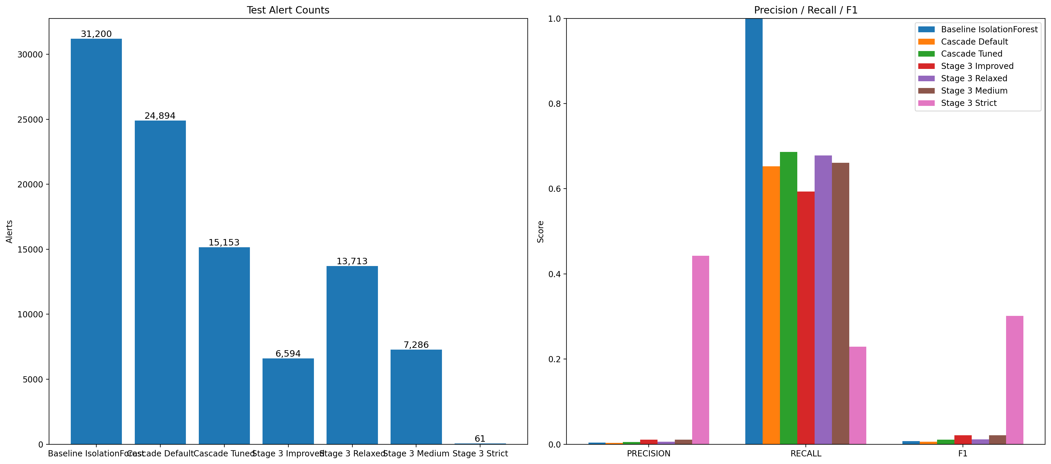
Figure 1: Model Comparison - Test Alerts and Core Metrics
Figure 1: Model Comparison - Test Alerts and Core Metrics.
The baseline Isolation Forest produced 31,200 test alerts. It had recall of 1.0000, meaning it captured all known anomaly rows in the held-out test set. However, its precision was 0.0038, which means that only about four alerts out of every 1,000 were true anomaly detections. This made the baseline useful as a high-sensitivity benchmark, but too noisy as a practical alerting approach.
Figure 2 shows how the selected Stage 3 Improved cascade narrowed the alert stream from broad screening to final confirmation.
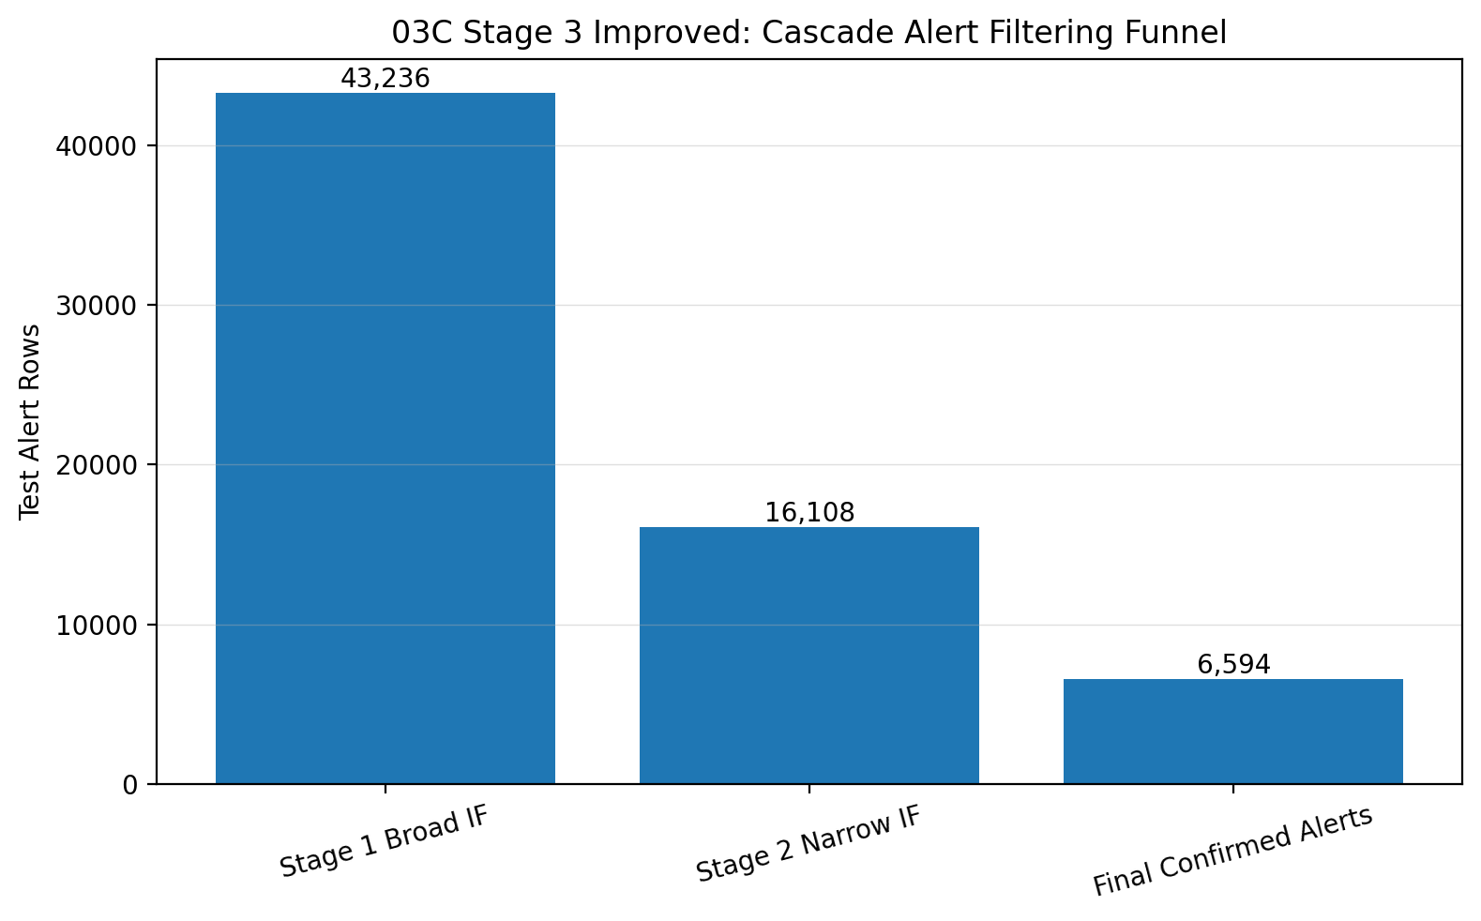
Figure 2: Stage 3 Improved Cascade Filtering Funnel
Figure 2: Stage 3 Improved Cascade Filtering Funnel.
The default cascade reduced test alerts to 24,894, but its precision and F1 score did not improve over the baseline. This showed that a cascade structure alone was not enough. The cascade needed better tuning and confirmation logic.
The tuned cascade improved the result. It reduced test alerts to 15,153 and improved F1 score to 0.0106. This showed that Stage 2 tuning improved the alert-quality tradeoff.
The Stage 3 Improved cascade produced the strongest main-model result. It reduced test alerts to 6,594, which was 24,606 fewer alerts than the baseline and an alert reduction of approximately 78.9%. Precision improved from 0.0038 to 0.0106, and F1 score improved from 0.0075 to 0.0209. Recall decreased to 0.5932, which was expected because the final model was intentionally more selective.
Figure 3 summarizes the Stage 3 operating-mode tradeoff between alert burden and F1 score.
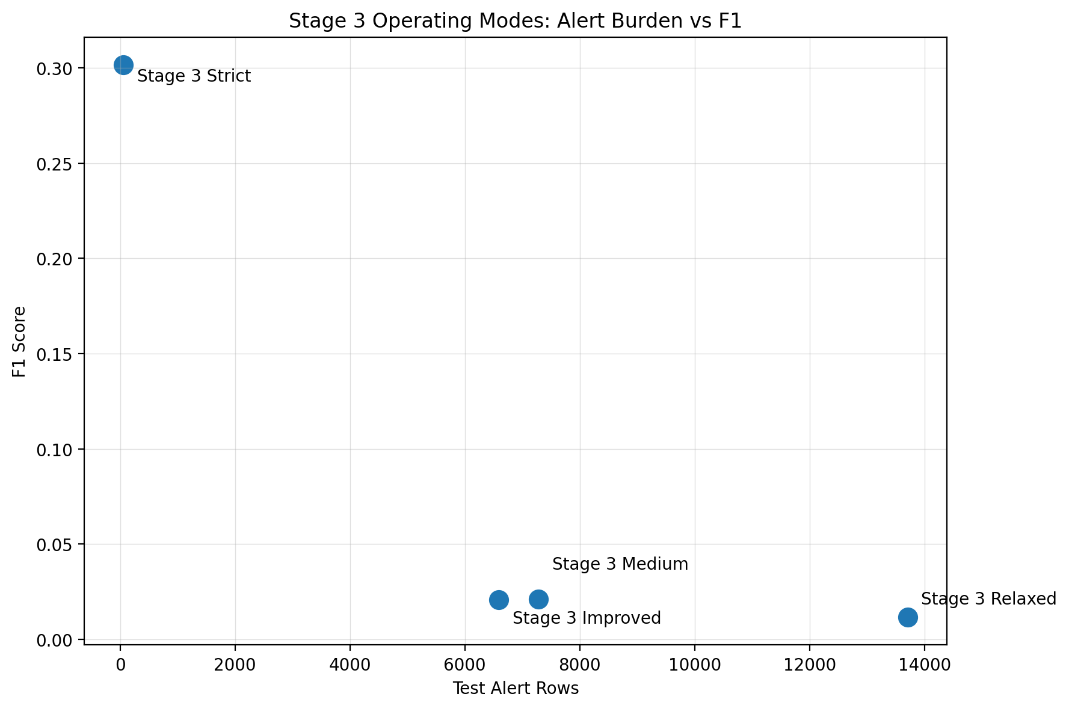
Figure 3: Stage 3 Operating Mode Comparison
Figure 3: Stage 3 Operating Mode Comparison.
Stage 3 Strict had the highest precision and F1 score, but it only produced 61 test alerts and had recall of 0.2288. Because of that, it was not selected as the main final model. It is better interpreted as a conservative audit mode. Stage 3 Medium was a strong alternate operating mode because it had slightly higher F1 than Stage 3 Improved while producing more alerts.

F.2 Statistical Evaluation
The final statistical comparison evaluated whether the Stage 3 Improved cascade differed meaningfully from the baseline. The primary comparison used the same held-out test rows for both models.
Three statistical tests were used:
- McNemar paired test: Compared row-level correctness between the baseline and Stage 3 Improved cascade.
- False-positive-rate z-test: Compared the false-positive rate during normal test rows.
- Precision z-test: Compared the concentration of true anomaly detections within each model’s alert stream.
The McNemar test was statistically significant with p < 0.001. This test was selected because McNemar’s test is designed for paired nominal outcomes, which matched the row-level baseline-versus-cascade comparison (statsmodels developers, n.d.). This indicated that the baseline and Stage 3 Improved cascade differed significantly in row-level prediction correctness.
The false-positive-rate z-test was also statistically significant with p < 0.001. This supported the planned hypothesis that the cascade would reduce false-positive behavior compared with the baseline.
The precision z-test was statistically significant with p < 0.001. This showed that the Stage 3 Improved cascade significantly improved true-alert concentration compared with the baseline.
These tests support the conclusion that the Stage 3 Improved cascade did more than reduce alerts visually or descriptively. It produced a statistically significant reduction in normal-row false positives and a statistically significant improvement in alert quality.

F.3 Practical Significance
The practical significance of the project is that the cascade made the alert stream more manageable. In a maintenance setting, alert volume matters because each alert may require review. A model that produces too many alerts can create alert fatigue even if it detects all known anomaly rows.
The baseline produced 31,200 test alerts. The Stage 3 Improved cascade reduced that to 6,594 test alerts. This means the selected cascade removed 24,606 alerts from the test alert stream compared with the baseline. That reduction is practically important because it would allow maintenance staff or analysts to focus on a smaller set of higher-priority abnormal periods.
The precision improvement is also practically meaningful. The baseline produced about four true anomaly detections per 1,000 alerts. The Stage 3 Improved cascade produced about eleven true anomaly detections per 1,000 alerts. Even though precision was still low because the dataset was extremely imbalanced, the cascade produced a more concentrated alert stream.
Figures 4 and 5 support the early-warning interpretation by showing lead-time behavior and the selected anomaly timeline.
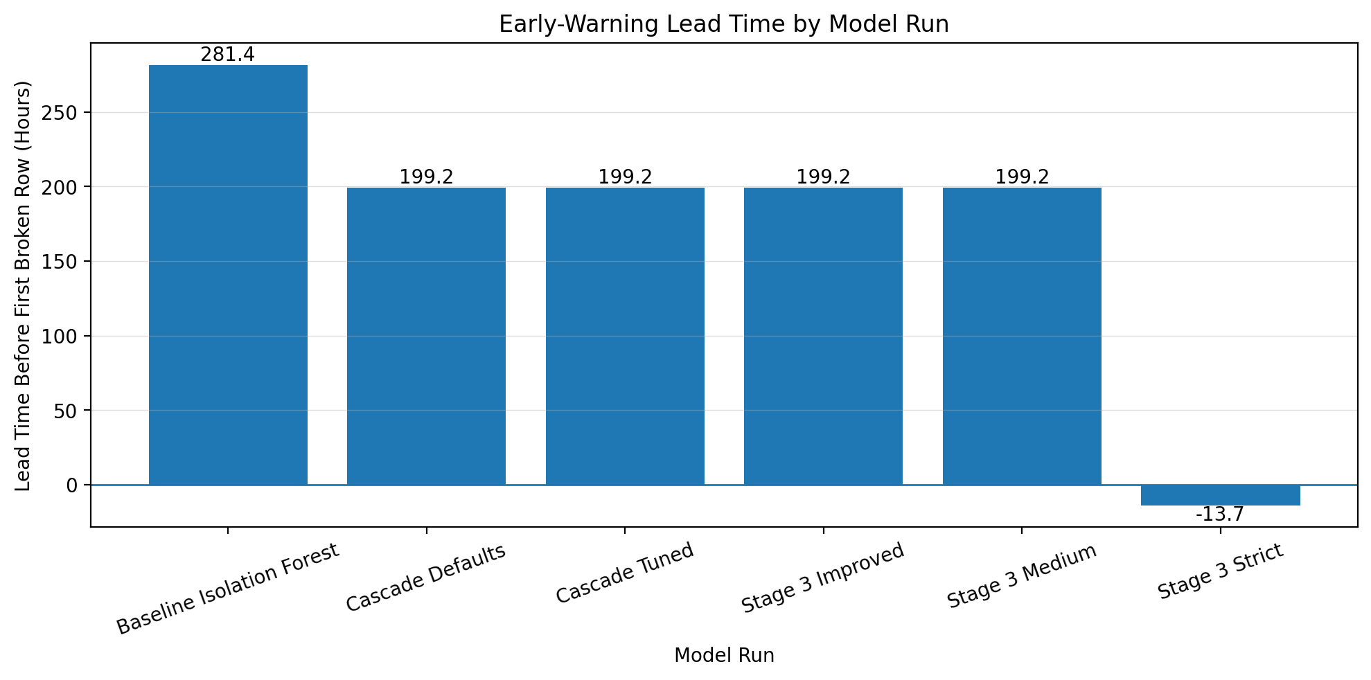
Figure 4: Multi-Run Lead-Time Comparison
Figure 4: Multi-Run Lead-Time Comparison.
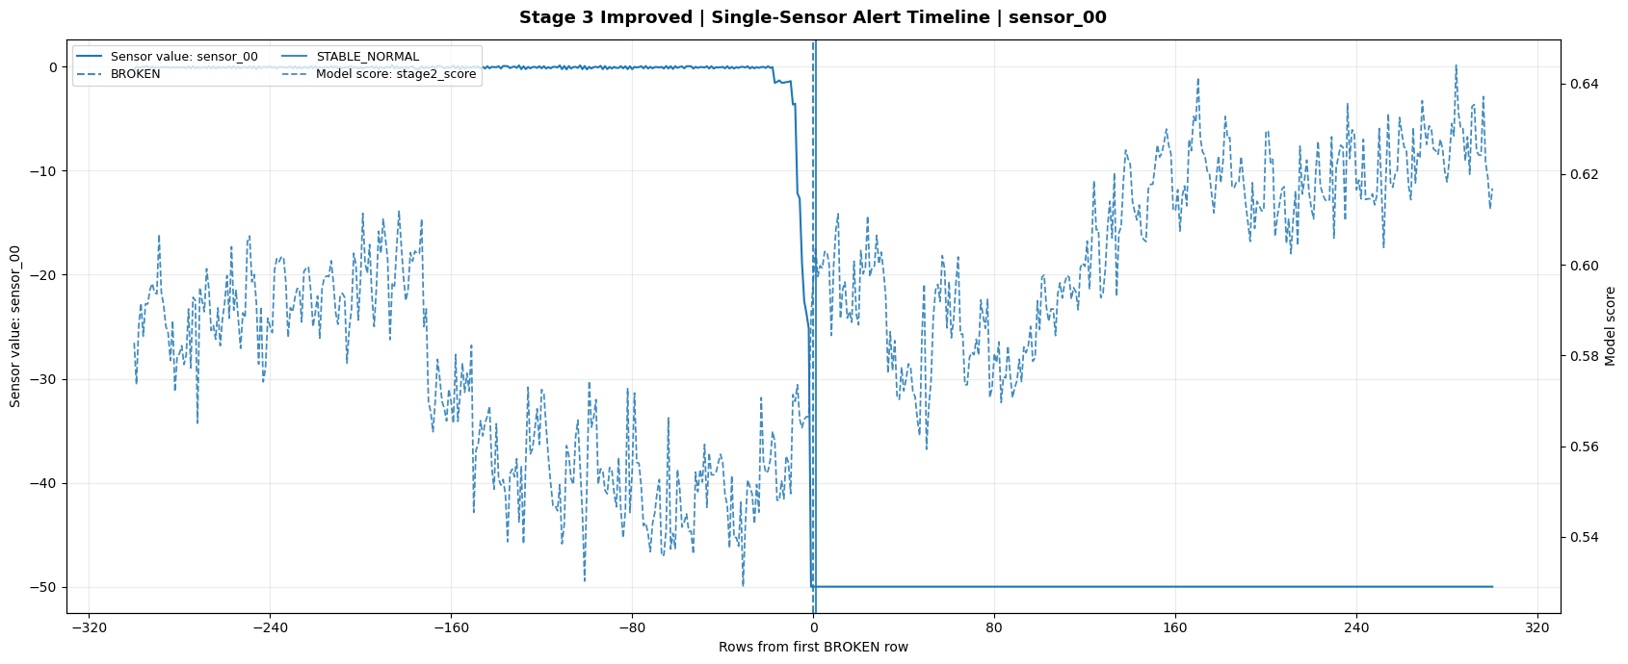
Figure 5: Stage 3 Improved Anomaly Timeline
Figure 5: Stage 3 Improved Anomaly Timeline.
The timeline analysis also supported practical significance. The selected Stage 3 Improved cascade produced its first final alert at row 5,201, while the first broken row occurred at row 17,155. Because the data is minute-level, this represents approximately 11,954 minutes, or 199.2 hours, of early-warning evidence in the evaluated sequence.
This result should be interpreted carefully. It does not prove that the model is production-ready or that it can predict every future failure. It does show that the cascade identified abnormal behavior before the recorded broken state in this dataset.

F.4 Overall Success and Effectiveness
The project was successful because it answered the research question with both statistical and practical evidence. The baseline Isolation Forest proved that anomaly signal existed in the pump sensor data. However, it also showed the weakness of a single broad anomaly detector: it generated too many alerts.
The cascade experiments showed that staged filtering improved the practical usefulness of the alert stream. Gold 03A showed the first default cascade result. Gold 03B showed that Stage 2 tuning improved the tradeoff. Gold 03C showed that Stage 3 confirmation logic created the strongest main-model alert stream.
The final selected model, Stage 3 Improved, reduced alert volume, improved precision, improved F1 score, and preserved useful anomaly sensitivity. The statistical tests also supported that the difference from the baseline was significant. The project therefore achieved its core analytical goal.
The project was not intended to be a finished production system. It still needs additional validation, event-level evaluation, pipeline refactoring, and potential database integration. However, within the scope of the capstone, the project successfully demonstrated that a multi-stage cascade can produce more operationally useful anomaly alerts than a single Isolation Forest baseline.

G. Key Takeaways, Storytelling, and Recommendations

G.1 Conclusions Drawn from the Analysis
The analysis led to five main conclusions. First, the pump sensor data contained detectable anomaly signal because the baseline Isolation Forest captured all known anomaly rows in the held-out test set. Second, high recall was not enough by itself. The baseline achieved perfect recall, but it produced 31,200 test alerts, which would be difficult to review in a maintenance setting. Third, the cascade improved practical alert quality by reducing test alerts by approximately 78.9% while improving precision and F1 score. Fourth, the Stage 3 operating modes served different purposes: Stage 3 Improved was the best main model, Stage 3 Medium was a strong alternate mode, and Stage 3 Strict was better suited for conservative high-confidence review. Fifth, the selected cascade provided early-warning evidence by producing alert activity before the first broken row in the evaluated timeline. That result should be described as earlier abnormal-pattern detection rather than guaranteed failure prediction.

G.2 Effective Storytelling Through Visuals
The visual communication strategy was designed to make the project story easy to follow: data preparation, model comparison, cascade filtering, operating-mode tradeoffs, and early-warning behavior.
Figure 1 supports the main result by showing test alerts and core metrics across the baseline and cascade models. This visual helps explain why the baseline was not selected even though it had the highest recall.
Figure 2 explains how the cascade reduces alerts. It shows Stage 1 broad screening, Stage 2 refinement, and Stage 3 final confirmation. This visual is important because it connects the model architecture to the practical goal of reducing alert burden.
Figure 3 explains why the highest F1 score is not automatically the best final operating choice. It shows that Stage 3 Strict has strong precision and F1, but produces very few alerts and has lower recall. This supports the decision to use Stage 3 Improved as the main selected model while retaining Stage 3 Medium and Stage 3 Strict as alternate modes.
Figures 4 and 5 support the early-warning discussion. They show whether model alerts appeared before or after the first broken row and help connect technical metrics to the maintenance use case.
These visuals are effective because they do not rely on one chart or one metric. They show the tradeoff between sensitivity, alert burden, precision, and timing. This gives the audience a clearer understanding of why the cascade is more useful than the baseline.

G.3 Recommended Courses of Action

Recommendation 1: Continue development with Stage 3 Improved as the main model
The first recommendation is to continue development using Stage 3 Improved as the primary model configuration. This model provided the strongest general-purpose balance between alert reduction and retained anomaly sensitivity. It reduced baseline test alerts by approximately 78.9%, improved precision, improved F1 score, and produced early-warning evidence in the timeline analysis.
Stage 3 Medium should be kept as a strong alternate operating mode. It may be useful in situations where slightly higher recall is more important than minimizing alert volume. Stage 3 Strict should be preserved as a conservative audit mode for high-confidence review, but it should not be the main early-warning model.
Future tuning should focus on Stage 3 threshold calibration, additional validation with more failure episodes, and review of whether alert packets or grouped events provide a better evaluation target than row-level alerts.

Recommendation 2: Convert the notebook workflow into a modular pipeline and add event-level evaluation
The second recommendation is to convert the current notebook workflow into modular pipeline scripts after Task 3. The notebooks are appropriate for the capstone because they show the analysis process clearly, but a scripted pipeline would make the project easier to rerun, test, schedule, and extend.
The next version should also add event-level evaluation. The current model results are mostly row-level. Row-level metrics are useful for technical comparison, but maintenance teams are more likely to review alert events or alert packets. Grouping consecutive alert rows into events would provide a better measure of practical review burden.
PostgreSQL integration can be added later as part of this pipeline conversion. That integration would be useful for storing model outputs, comparison tables, timeline records, and dashboard-ready summaries. However, it should remain a future engineering extension unless it is completed and clearly separated from the core Task 3 evidence.

H. Panopto Recording
The Panopto recording link will be added after the final presentation is recorded and uploaded.
Panopto Link: [Insert Panopto recording link here]
The recording will summarize the capstone project for an audience of data analytics peers. It will include the research question, the organizational need, a demonstration of the notebook workflow, and a summary of the findings and implications.
The presentation should cover the following points:
- Research question and organizational need: Explain that the project evaluated whether a multi-stage anomaly detection cascade improved alert quality compared with a single Isolation Forest baseline for industrial pump sensor data.
- Data and workflow: Summarize the Kaggle pump sensor dataset and explain the Bronze, Silver, and Gold notebook workflow.
- Code functionality: Demonstrate how the notebooks move from raw ingestion, to Silver profiling, to Gold preprocessing, to baseline and cascade modeling.
- Model comparison: Show the baseline Isolation Forest, the default cascade, the tuned cascade, and the Stage 3 Improved cascade.
- Final results: Explain that the Stage 3 Improved cascade reduced test alerts from 31,200 to 6,594, improved precision and F1 score, and produced statistically significant improvements compared with the baseline.
- Practical significance: Explain that the cascade reduced alert burden and provided early-warning evidence, while also clarifying that the project is not a production-ready deployment.
- Recommendations: Summarize the two main recommendations: continue development with Stage 3 Improved as the main model and convert the notebook workflow into a modular pipeline with event-level evaluation.
This section will be finalized after the Panopto URL is available.

I. Evidence of Project Completion
Evidence of project completion is provided through the submitted project files, notebooks, project documentation, and generated artifacts. The evidence package represents the completed analytical workflow from raw data ingestion through model comparison and anomaly timeline review.
The main notebook deliverables are:
- Bronze preprocessing notebook.
- Silver Pre-EDA notebook.
- Silver subset and clean-normal profiling notebook.
- Silver EDA notebook.
- Gold preprocessing notebook.
- Gold 02 baseline Isolation Forest notebook.
- Gold 03A default cascade notebook.
- Gold 03B tuned cascade notebook.
- Gold 03C Stage 3 Improved cascade notebook.
- Gold 04 model comparison notebook.
- Gold 05 anomaly detection and timeline notebook.
The supporting project evidence includes:
- Model comparison summaries.
- Statistical test summaries.
- Confusion-count and metric outputs.
- Alert-reduction visualizations.
- Cascade funnel visualizations.
- Stage 3 operating-mode visualizations.
- Multi-run lead-time comparison outputs.
- Anomaly timeline plots.
- Component writeups for model results.
- Project configuration files.
- Utility scripts used by the notebook workflow.
- Project documentation for Task 2 and Task 3.
The raw data source is the publicly available Pump Sensor Data dataset from Kaggle (nphantawee, n.d.). The source data, project notebooks, and generated outputs are sufficient to show the completed analytical process. Some large parquet and CSV exports may be excluded from the compressed submission package because of file-size limitations, but the notebooks, code, summaries, visualizations, and documentation provide evidence that the project workflow was completed.
The project also contains supporting framework work related to future pipeline conversion, synthetic data testing, Kafka, and PostgreSQL. These items are not presented as the main Task 3 deliverables. They are included only as supporting or future-development context. The core project evidence remains the Bronze, Silver, and Gold analytical notebooks and the model comparison results.

J. Sources
Ahmad, S., Purdy, S., Lavin, A., & Agha, G. (2019). Evaluating real-time anomaly detection algorithms - The Numenta anomaly benchmark. arXiv. https://arxiv.org/abs/1906.03821
Bose, S., Zhang, T., & Ramaswamy, L. (2025). Cascading multi-agent anomaly detection in surveillance systems via vision-language models and embedding-based classification (Version 3). arXiv. https://arxiv.org/abs/2601.06204
Confluent. (n.d.). Python clients for Apache Kafka. https://docs.confluent.io/platform/current/clients/python.html
Databricks. (n.d.). What is medallion architecture? https://www.databricks.com/glossary/medallion-architecture
Docker, Inc. (n.d.). Develop with Docker: Best practices. https://docs.docker.com/develop/
Gómez, J., Suárez, J., Pantoja, A., & Camargo, J. (2023). An adaptable and unsupervised TinyML anomaly detection system for extreme industrial environments. Sensors, 23(4), 2034. https://doi.org/10.3390/s23042034
Himeur, Y., Sun, Y., & Ghanem, K. (2021). Hybrid anomaly detection in industrial IoT systems. arXiv. https://arxiv.org/abs/2103.11320
nphantawee. (n.d.). Pump sensor data [Data set]. Kaggle. https://www.kaggle.com/datasets/nphantawee/pump-sensor-data/data
pandas development team. (n.d.). pandas user guide. https://pandas.pydata.org/docs/user_guide/index.html
scikit-learn developers. (n.d.-a). IsolationForest. https://scikit-learn.org/stable/modules/generated/sklearn.ensemble.IsolationForest.html
scikit-learn developers. (n.d.-b). Outlier detection. https://scikit-learn.org/stable/modules/outlier_detection.html
scikit-learn developers. (n.d.-c). Precision, recall, F-measure and support. https://scikit-learn.org/stable/modules/generated/sklearn.metrics.precision_recall_fscore_support.html
scikit-learn developers. (n.d.-d). RobustScaler. https://scikit-learn.org/stable/modules/generated/sklearn.preprocessing.RobustScaler.html
statsmodels developers. (n.d.). McNemar test. https://www.statsmodels.org/dev/generated/statsmodels.stats.contingency_tables.mcnemar.html
Tam, K.-Y., & Nguyen, D. T. (1995). Expert-system rule validation for anomaly alarms. IEEE Transactions on Systems, Man, and Cybernetics, 25(2), 309-319. https://ieeexplore.ieee.org/document/494139/
Weights & Biases. (n.d.). Artifacts. https://docs.wandb.ai/guides/artifacts
Zhang, X., Wang, L., & Wang, P. (2019). Combining statistical profiles with machine learning for industrial condition monitoring. Sensors, 19(21), 4734. https://www.mdpi.com/1424-8220/19/21/4734
Zhou, X., Wang, Y., Lu, Y., & Ting, K. M. (2024). Fast anomaly detection for vision-based industrial inspection using cascades of null subspace PCA detectors. Sensors, 24(3), 1234. https://pmc.ncbi.nlm.nih.gov/articles/PMC12349016/

